KIDS ONE MINUTE WORK OUTS FOR SELF REGULATION
Set the time and complete each animal movement for 45 seconds, have 15 seconds rest between, do as many as you can.
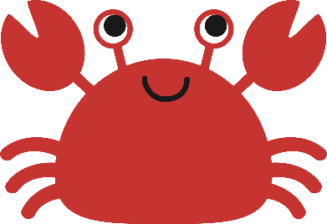
1. Kids (and parents) should not eat right before doing yoga. It is best not to have a full stomach when practicing the postures.
2. Pick a quiet place to do yoga with your child. Preferably practice on a yoga mat or soft carpet. Using a yoga mat helps ground kids and gives them a personal space to do the postures.
3. Do the poses with your child.
4. Enjoy being with your child, and try to be in the moment rather than letting your mind wander to things you need to get done.
5. Start in the Candle pose by kneeling on the floor with your hands in prayer position in front of your heart. Take several breaths in and out through your nose before advancing to other poses.
6. Remember to always breathe in and out of your nose when practicing yoga postures.

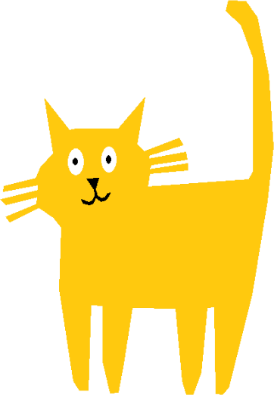
7. Keep the tone light and fun, and never push your child to do more than they are capable of.
8. Give your child positive reinforcement to help him or her learn and improve.
9. Your final posture should be the Do Nothing Pose, where you and your child lie on your backs with your arms alongside your body and your palms facing towards the ceiling. If you have an eye pillow or small towel to cover your eyes, it helps to keep the light out.
Yoga Precautions for Children
Children tend to have looser joints and great enthusiasm. As a result, they may be unaware when they are stretching beyond what is safe. Parents without yoga backgrounds who are interested in incorporating yoga should seek proper guidance and instruction. Parents practicing independently with their children should be aware that upside-down poses (such as headstands) pose great risk to children who have limited body awareness.

